Ex.No: 3 Roll.No: 210701193

# PYTHON PROGRAM TO CREATE A NEURAL NETWORK TO RECOGNIZE HANDWRITTEN DIGITS USING MNIST DATASET

Aim:

To create a neural network to recognize handwritten digits using MNIST

dataset in python.

# Procedure:

1. Import TensorFlow, Keras, and Matplotlib for building the model and plotting.
2. Load the MNIST dataset, consisting of handwritten digits.
3. Reshape and normalize the training and test images to have pixel values between 0 and 1.
4. Convert the training and test labels to one-hot encoded vectors.
5. Build a Sequential model and add a Conv2D layer with 32 ﬁlters and ReLU activation.
6. Add a MaxPooling layer, followed by another Conv2D layer with 64 ﬁlters and ReLU activation.
7. Add a third Conv2D layer, ﬂatten the output, and add a Dense layer with 64 units and ReLU activation.
8. Add a ﬁnal Dense layer with 10 units and softmax activation for classiﬁcation.
9. Compile the model with Adam optimizer and categorical cross-entropy loss, and train it for 5 epochs with 20% validation split.
10. Evaluate the model on test data and plot the training and validation accuracy and loss over epochs.

# Code:

# Import necessary libraries import tensorﬂow as tf

from tensorﬂow.keras import layers, models from tensorﬂow.keras.datasets import mnist import matplotlib.pyplot as plt

# Load the MNIST dataset

(train_images, train_labels), (test_images, test_labels) = mnist.load_data()

# Preprocess the data

train_images = train_images.reshape((60000, 28, 28, 1)).astype('ﬂoat32') / 255

test_images = test_images.reshape((10000, 28, 28, 1)).astype('ﬂoat32') / 255

# Convert labels to one-hot encoding

train_labels = tf.keras.utils.to_categorical(train_labels) test_labels = tf.keras.utils.to_categorical(test_labels)

# Build the neural network model model = models.Sequential()

model.add(layers.Conv2D(32, (3, 3), activation='relu', input_shape=(28, 28, 1)))

model.add(layers.MaxPooling2D((2, 2)))

model.add(layers.Conv2D(64, (3, 3), activation='relu'))

model.add(layers.MaxPooling2D((2, 2)))

model.add(layers.Conv2D(64, (3, 3), activation='relu')) model.add(layers.Flatten()) model.add(layers.Dense(64, activation='relu')) model.add(layers.Dense(10, activation='softmax'))

# Compile the model model.compile(optimizer='adam',

loss='categorical_crossentropy', metrics=['accuracy'])

# Train the model

history = model.ﬁt(train_images, train_labels, epochs=5, batch_size=64, validation_split=0.2)

# Evaluate the model on test data

test_loss, test_acc = model.evaluate(test_images, test_labels) print(f'Test accuracy: {test_acc}')

# Plot the accuracy and loss over epochs plt.ﬁgure(ﬁgsize=(12, 4))

plt.subplot(1, 2, 1)

plt.plot(history.history['accuracy'], label='Training Accuracy') plt.plot(history.history['val_accuracy'], label='Validation Accuracy') plt.xlabel('Epochs')

plt.ylabel('Accuracy') plt.legend()

plt.subplot(1, 2, 2)

plt.plot(history.history['loss'], label='Training Loss') plt.plot(history.history['val_loss'], label='Validation Loss') plt.xlabel('Epochs')

plt.ylabel('Loss') plt.legend()

plt.show()

# Output:

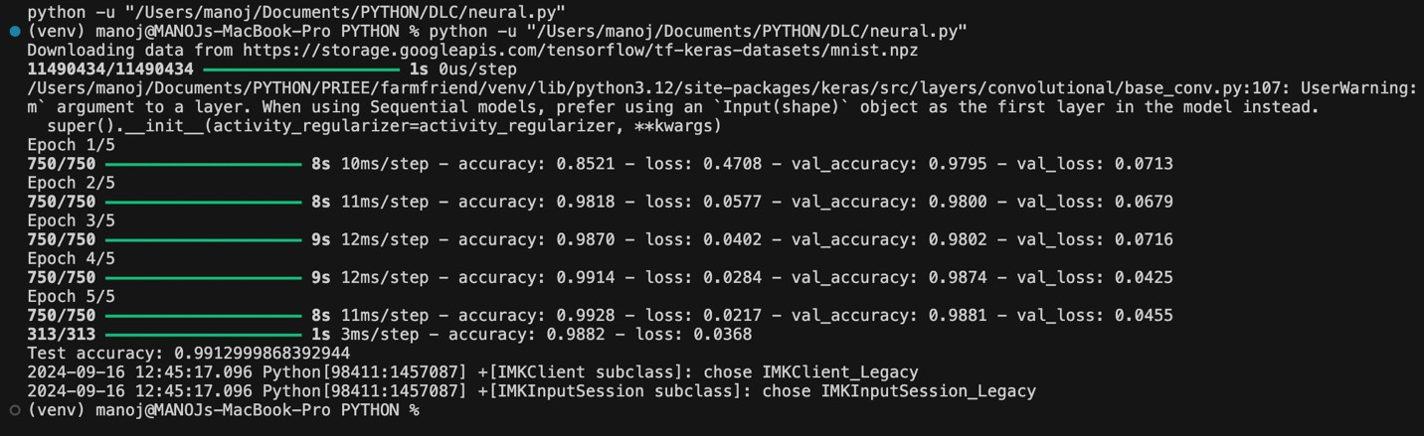

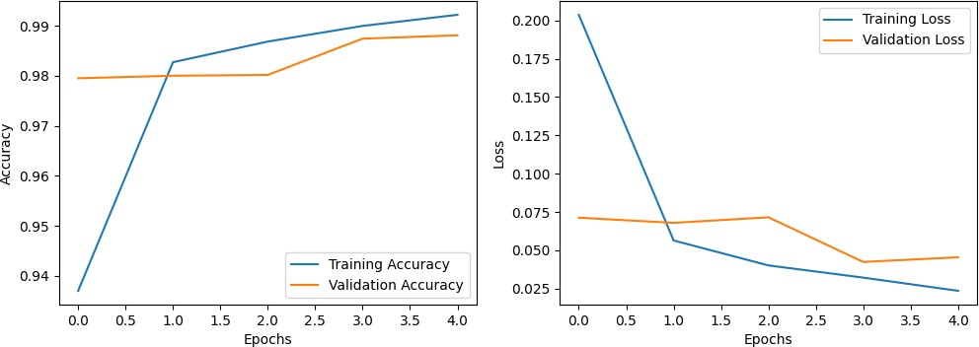

Result:

Thus, to implement neural network to recognize handwritten digits using MNIST dataset in python has been completed successfully.